An organisation in the sport and recreation sector can adopt the Code of Integrity for Sport and Recreation (the Integrity Code) by following the steps below. The Integrity Code is secondary legislation made by the Sport Integrity Commission Te Kahu Raunui (the Commission).

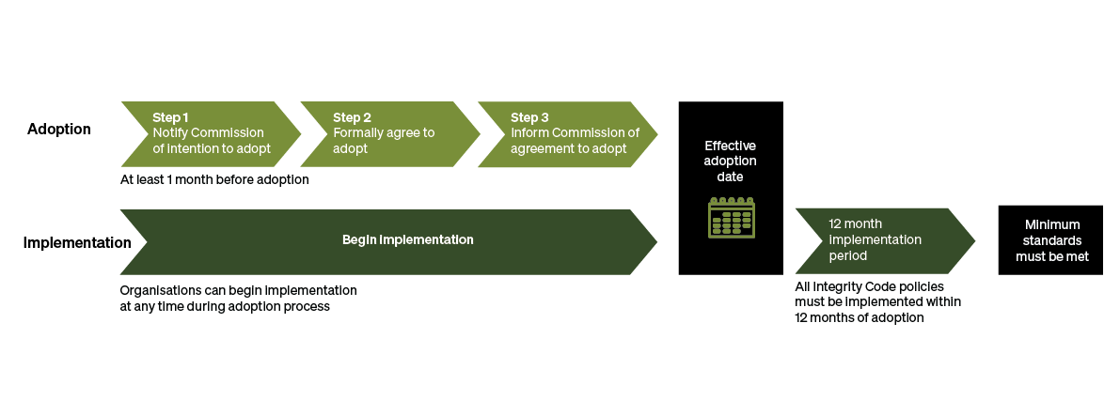

# Step 1 – Notify the Commission

An organisation starts the process by writing to us saying it intends to adopt the Integrity Code.

The organisation will need to tell us about its structure, its members and how it proposes to get itself ready to comply with the Integrity Code.

We will then review this information and offer guidance and assistance on the practical steps that should be taken before adoption, or whether the organisation is well placed to adopt the Integrity Code at all.

# Step 2 – Formally adopt the Integrity Code

To formally adopt the Integrity Code, the organisation must amend its constitution and ensure its members understand and agree that they are bound by the Integrity Code.

An organisation can also ask for a dispensation from complying with part of the Integrity Code because it’s not relevant, necessary, or legally able to implemented. But we need to agree to the dispensation.

# Step 3 – Provide a copy of the resolution to the Commission

The organisation will need to provide us with a copy of the formal resolution adopting the Integrity Code. Once we are satisfied that the adoption requirements are met, we will add the organisation to the public list of organisations that have adopted the Integrity Code.

From the date of adoption, the organisation will have 12 months to comply with the minimum standards set out in the Integrity Code.

While any organisation in the sector can adopt, we strongly recommend that national-level organisations adopt the Integrity Code, rather than the regional or local level organisations.

## Have your say

We want to hear your views on the draft Integrity Code. Find more information about the Integrity Code and how to make a submission at haveyoursay.sportintegrity.nz.

Submissions close on 1 November 2024.